PYTHAGORAS
Q. 1: Solve the following:
1. Identify, with reason, which of the following are Pythagorean triplets.
1. (24, 70, 74) [2]
2. 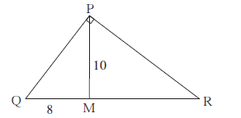 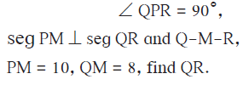 [2]
3. Find the side and perimeter of a square whose diagonal is 10 cm. [2]
4. 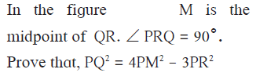 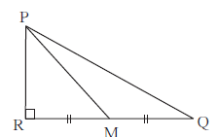 [3]
5. In Δ ABC, AB = 10, AC = 7, BC = 9 then find the length of the median drawn from point C to side AB

MENSURATION

Q. 2: Solve the following:
1. The dimensions of a cuboid are 44 cm, 21 cm, 12 cm. It is melted and a cone of height 24 cm is made. Find the radius of its base. [2]
2. 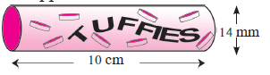
a cylindrical wrapper of flat tablets is shown. The radius of a tablet is 7 mm and its thickness is 5 mm. How many such tablets are wrapped in the wrapper ?
3 Marks

3.

